Aim: To implement Regression in Python.

Theory:
Q1. What is Regression?
Regression is a statistical and machine learning technique used to model the relationship between a dependent variable (output) and one or more independent variables (inputs), mainly for prediction and trend analysis.

Q2. List applications of Regression.
- Predicting house prices
- Sales and revenue forecasting
- Stock market trend analysis
- Demand prediction in businesses
- Risk assessment in finance
- Weather forecasting
- Healthcare outcome prediction

Q3. What is Linear Regression?
Linear regression is a statistical method used to model the relationship between two variables by fitting a straight line to observed data.
- An independent variable (predictor, XX)
- A dependent variable (outcome, YY)
Linear regression finds the best straight line that predicts YY from XX.

Q4. Write a Python program to implement the Linear Regression.
Code:
df = pd.read_csv('games_data.csv')

num_cols = df.select_dtypes(include=[np.number]).columns.tolist()
X = df[[num_cols[0]]].values
y = df[num_cols[1]].values

X_b = np.c_[np.ones((len(X),1)), X]
theta = np.linalg.pinv(X_b.T @ X_b) @ X_b.T @ y
y_pred = X_b @ theta

plt.figure()
plt.scatter(X, y)
plt.plot(X, y_pred)
plt.title('Linear Regression')
plt.xlabel(num_cols[0])
plt.ylabel(num_cols[1])
plt.show()

R = np.corrcoef(X.flatten(), y)[0,1]
print("R =", R)

Output:
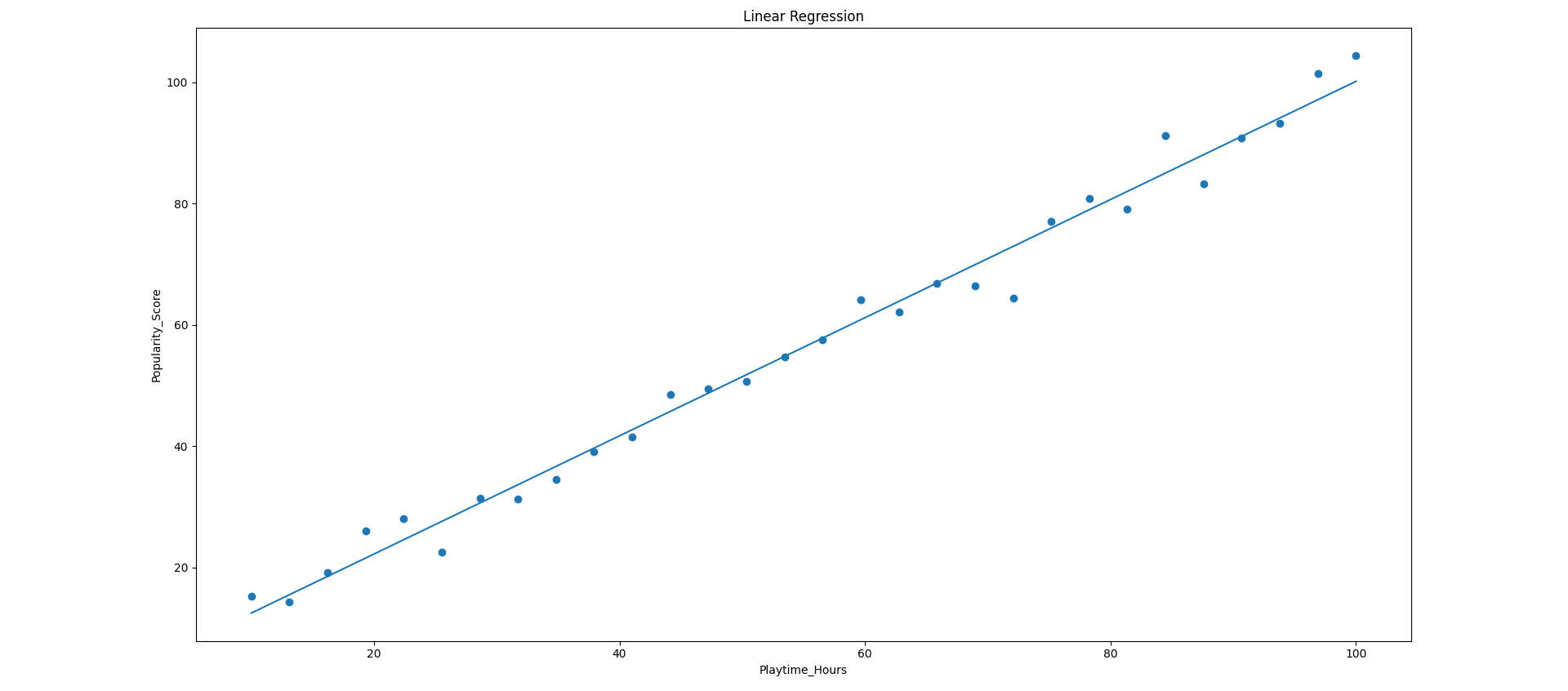
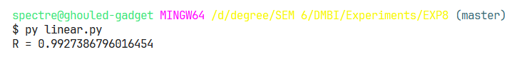

Conclusion:
Successfully implemented Linear Regression in Python.

